Q1.
Answer is A.

A: Correct one.
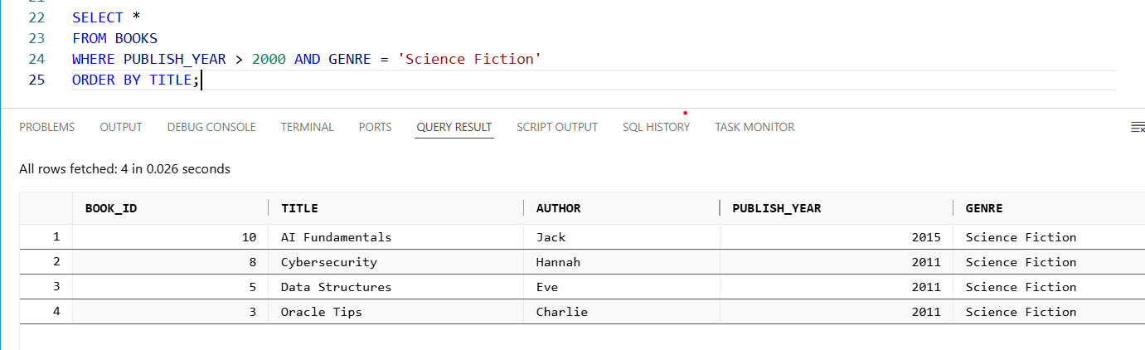

B: OR would include all books published after 2000 plus all Science Fiction books, even those published before 2000.
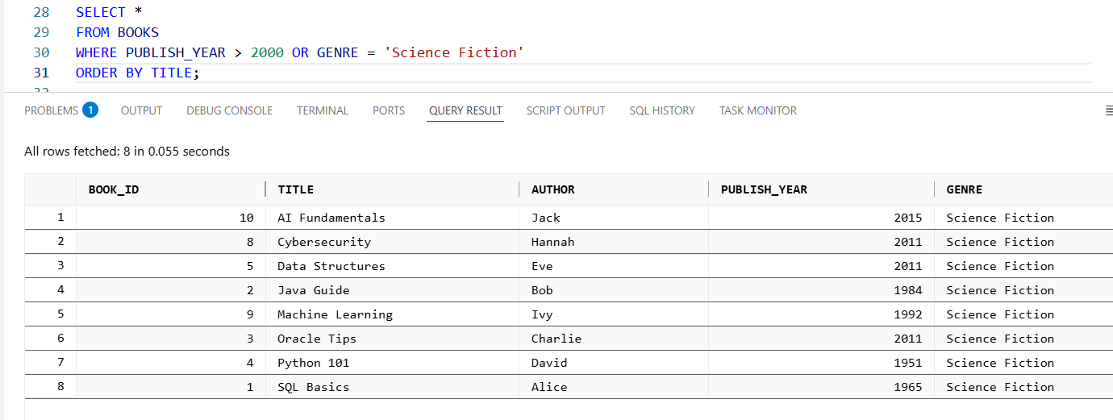

C: HAVING is only used with GROUP BY to filter aggregated results.
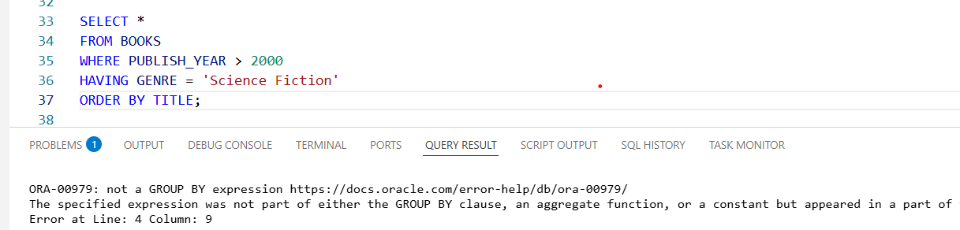

D: Incorrect. GROUP BY GENRE = 'Science Fiction' is syntactically wrong.
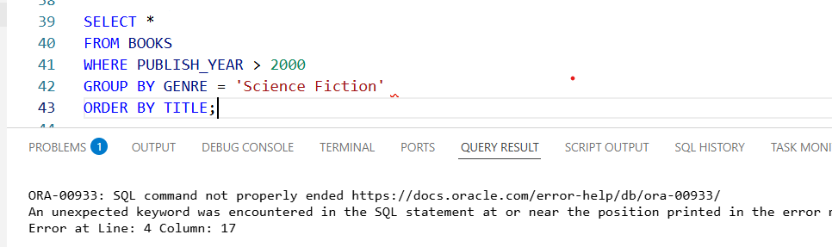

Q2.
Answer is D.

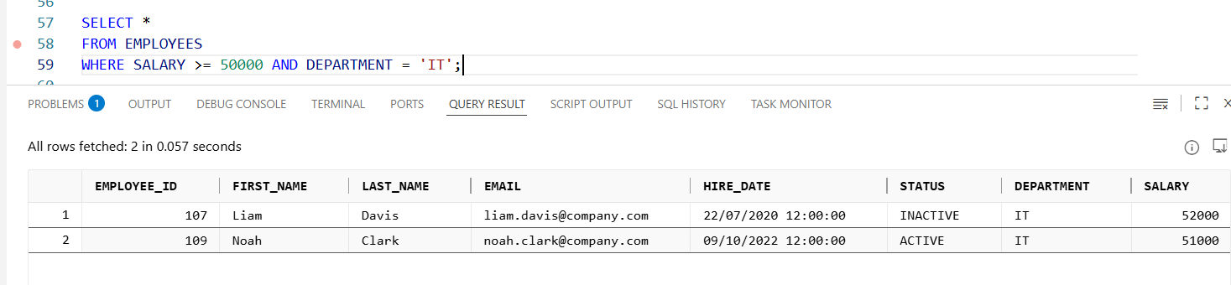

A: If the table doesn’t exist, the query would throw an error.

B: The query uses SALARY >= 50000, not = 50000.

C: If SALARY is stored as a string (VARCHAR/CHAR), the >= 50000 comparison may not work correctly.

D: If all IT employees have salaries below 50000 (e.g., 45000, 48000, etc.), then the query will correctly return zero rows.

Q3.
Answer is A.

A: Correct.
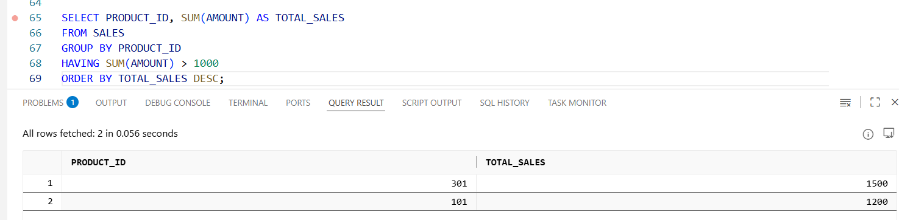

B: Incorrect.
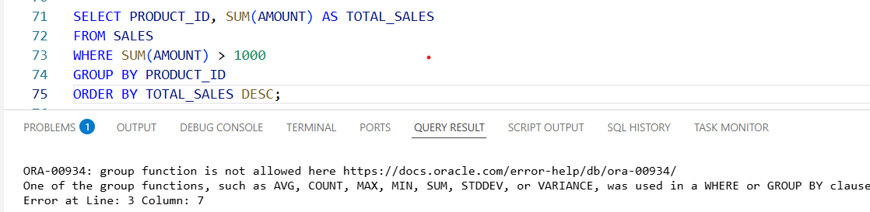

C: Only HAVING can filter after aggregation.
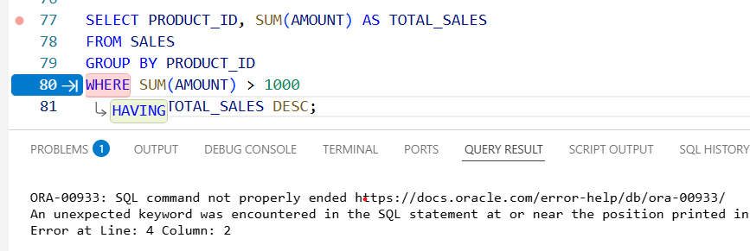

D: GROUP BY must come before HAVING.But also valid in Oracle 21c.
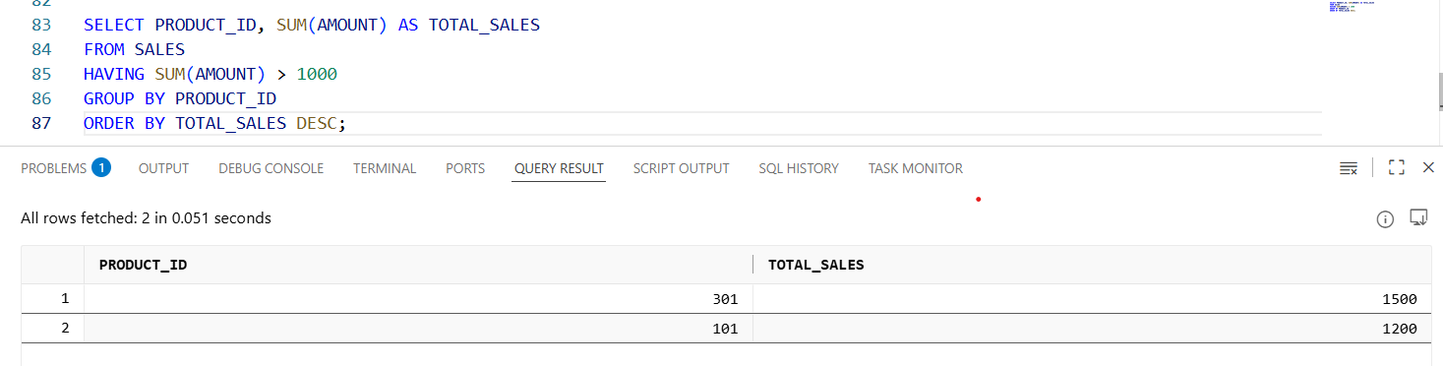

Q4.
Answer is B.

A: Incorrect. SELECT is not evaluated first. The engine must know which rows exist (FROM) and which pass filters (WHERE) before it can compute the SELECT list.

B: Correct.

C: Incorrect. This says you compute SELECT before applying WHERE. But WHERE filters occur before projection; you cannot reference SELECT aliases in WHERE because the projection hasn’t been evaluated yet.

D: Incorrect. WHERE depends on the rows produced by FROM; you cannot filter before producing rows.

Q5.
Answer is A.

A: Correct.
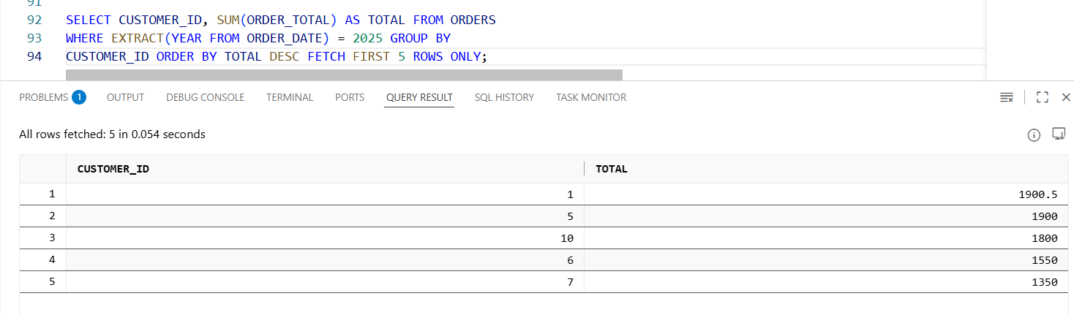

B: correct only for SQL Server (syntax TOP 5).
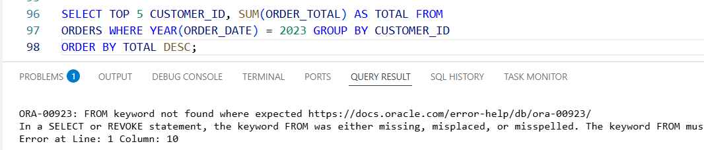

C: not portable; function-on-column hurts indexes.
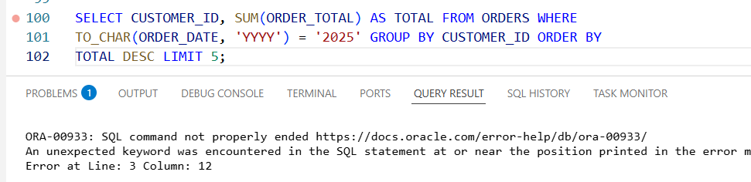

D: Incorrect as written — ROWNUM is misused and BETWEEN may be unsafe for datetimes.
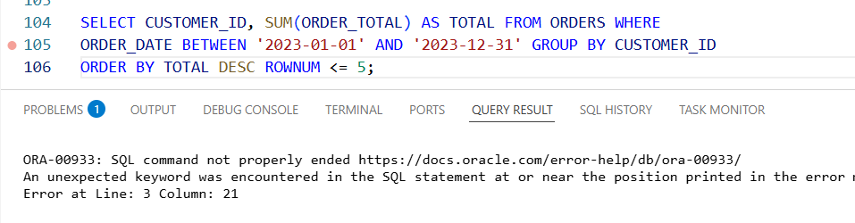

Q6.
Answer is B.

A: Incorrect. It is ascending by default.
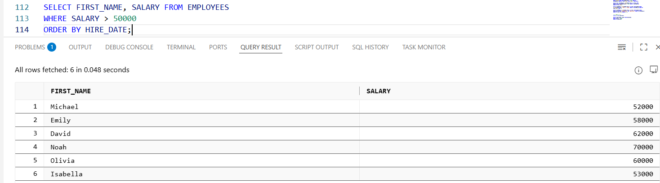

B: Condition is correct and sorts in descending order.
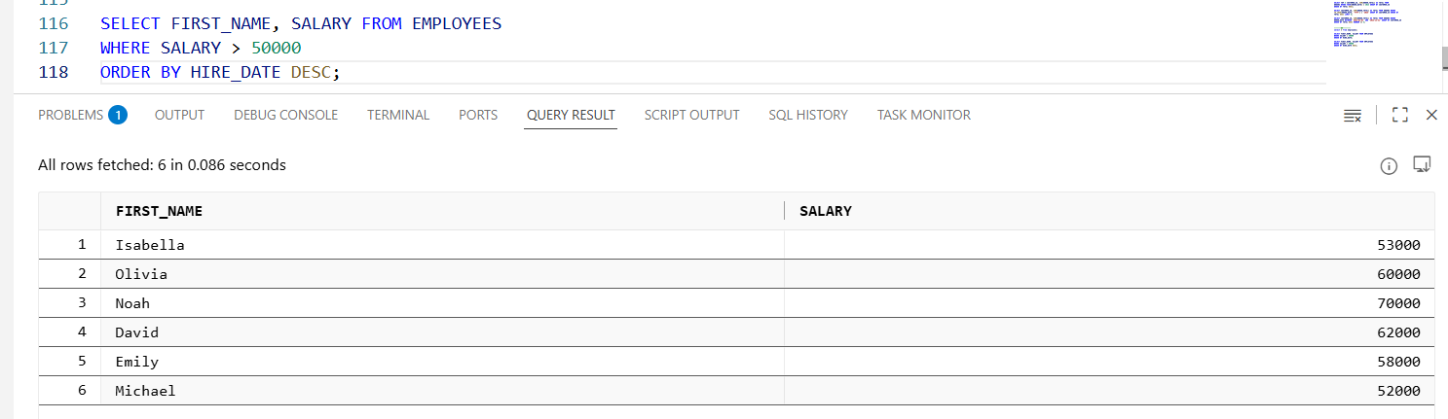

C: Incorrect, includes one extra group of employees (equal to 50,000).
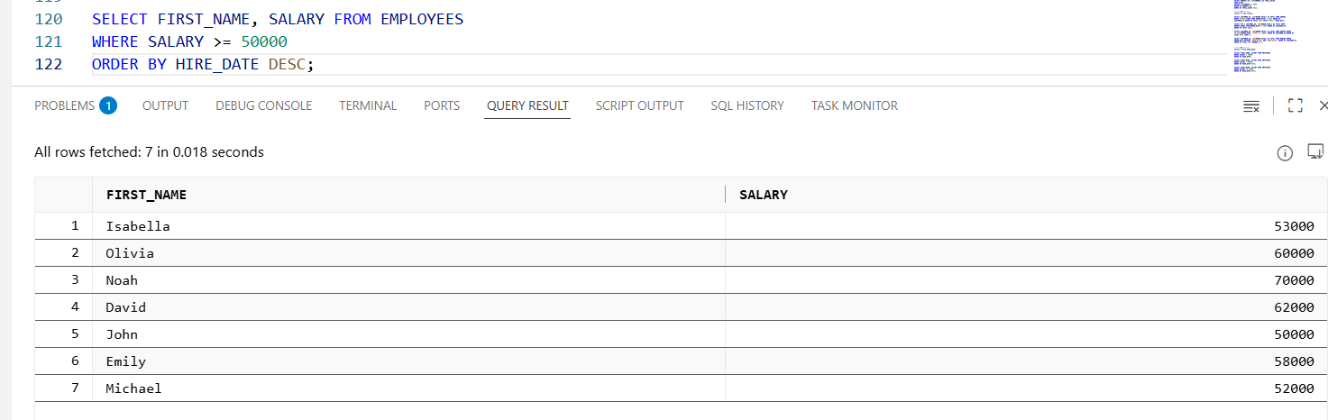

D: Also correct but question want only return name.
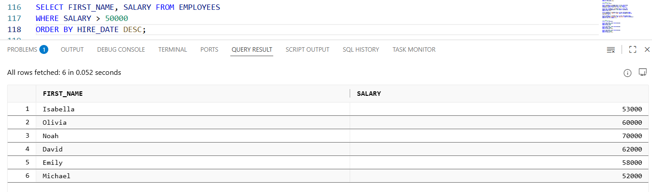

Q7.
Answer is B & C.

A: Incorrect. Sorts ascending by default and return all columns.
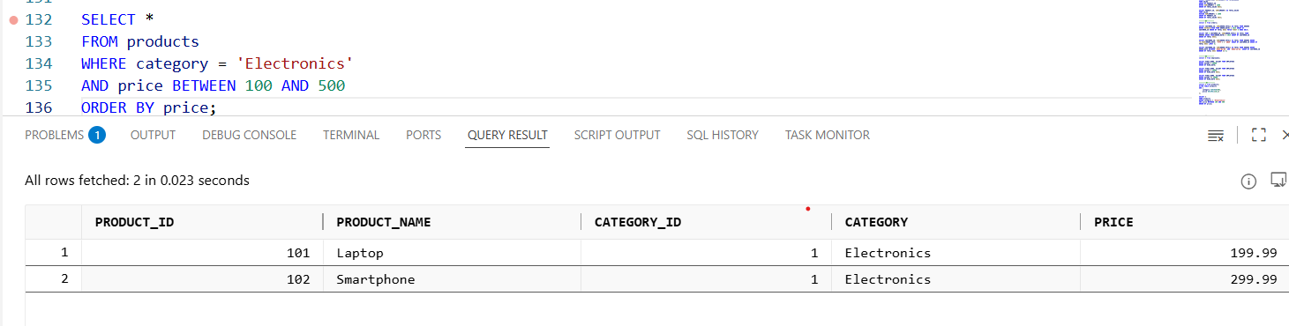

B: Correct all conditions.
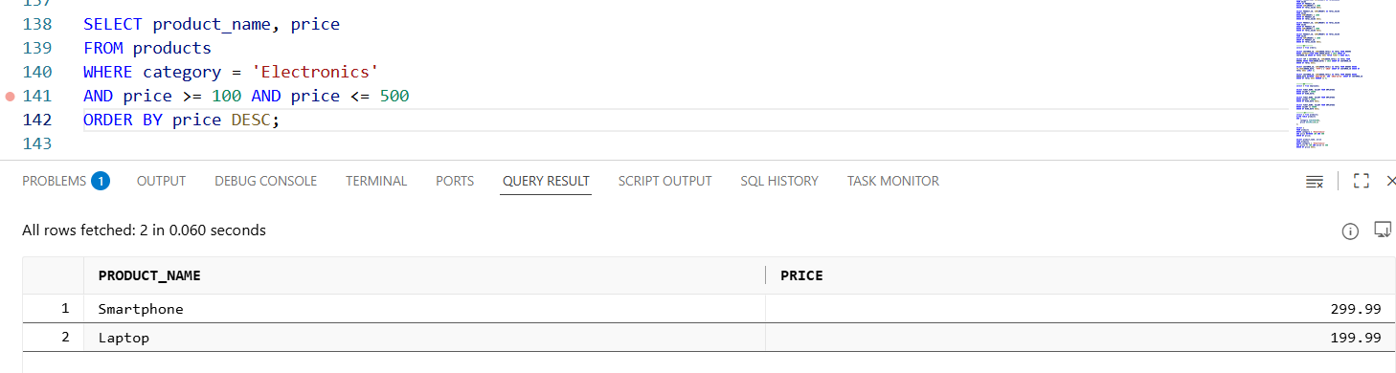

C: Correct, same as B.
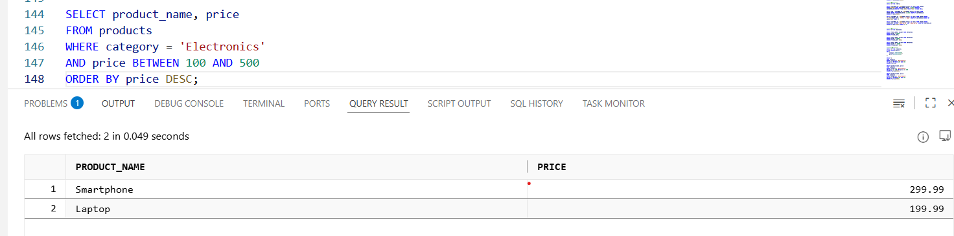

D: excludes boundary values and misses price column.
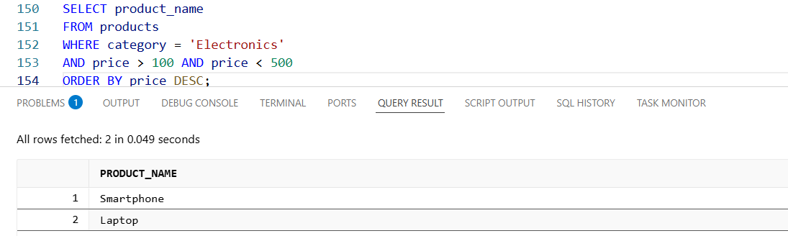

Q8.
Answer is

A: Incorrect. WHERE does not control columns.

B: Correct. it filters rows that meet a specified condition.

C: Incorrect. WHERE can be used in join conditions.

D: Incorrect. WHERE has no effect on the order of rows.

